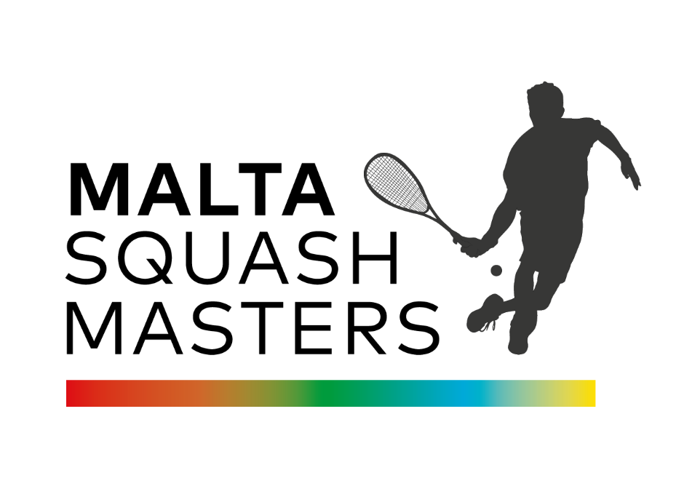
European Masters Grand Prix Event
4th – 6th December 2026

Click Here To Enter: tournament software link

Venue: Brand-new state-of-the-art National Squash Centre in Malta
Host venue of the European Team Championships & Youth Commonwealth Games
6 brand-new courts including one all glass show court (with seating for 350)
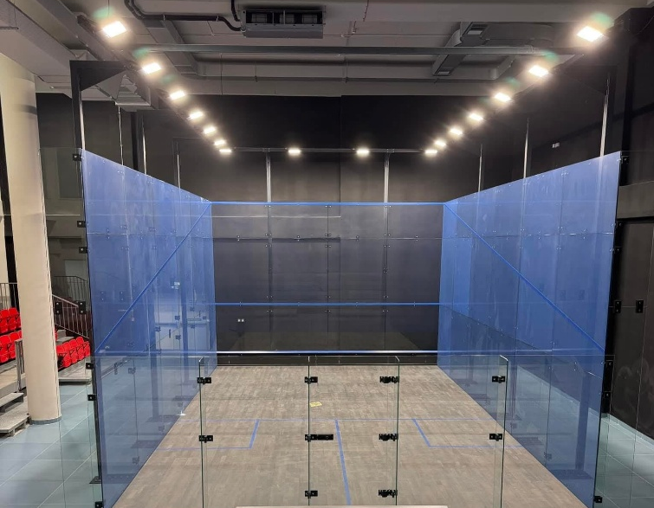
Show Court at brand-new National Squash Centre

Contacts
Tournament Director  Duncan Stahl  duncan@dwsevents.com | Tournament Referee  Ivan Balzan  maltasquash@gmail.com

Tournament software operator
Duncan Stahl
duncan@dwsevents.com

Date, Event category
This European Masters Grand Prix event will be held from 4th December to 6th December 2026. The tournament will start on 4th December at 09.00. The Prize Giving Ceremony takes place at the latest at 15.00 on 6th December.

Closing date for entries
25th November 2026: Entries may be closed before this date if the maximum number of entries of a category is reached.
Late entries are only acceptable before the seeding is published at the discretion of the Tournament Director and Masters Committee in the interest of the tournament.

Venue(s)
National Squash Centre, Aldo Moro St, Marsa, Malta
6 courts

Categories
Men: 35+, 40+, 45+, 50+, 55+, 60+, 65+, 70+
Women: 35+, 40+, 45+, 50+, 55+, 60+, 65+, 70+
The TD reserves the right to amalgamate age groups if there are insufficient entries to make a workable draw. Players are only allowed to enter one category.

Eligibility
This event is open to all players who are over 35, 40, 45, 50, 55, 60, 65, 70 on the first day of the event. As specified by the ESF, to compete in all ESF Registered events players must hold an active European Squash ID (ESID), which is approved and validated by his MNF and ESF. Objections to the entry of a player from an MNF must be made without delay after the entry of the player has been published. Players without a European Squash ID (ESID) can register through the ESF website: https://esf.tournamentsoftware.com/member/createorganizationaccount.aspx?id=8B5D0106-404D-41C3-B2FB-E6FE1BCEAB52

Seeding
The seeding will be carried out by the Masters Committee Seeding Panel using the latest available results and ESF Masters Rankings valid at the closing date and in accordance with the ESF Masters Circuit Guidelines. The TD will be consulted about seeding of local players.

Matches
All matches played will consist of the best of five games, under the rules of the WSF. All players are guaranteed a minimum of three matches. The Tournament Organisers will organise plate matches consisting of the best of five games. PAR 11 scoring (to 2 clear points) will be used.

Draws
Maximum draw size: 64 (3 day event).

Refereeing
Both players will be expected to mark and referee matches, usually the next match on the court, where they played.

Ball
DUNLOP PRO XX.

Prizes
To be determined at the discretion of the Tournament Director. The Prize Giving Ceremony takes place at the latest at 15.00 on 6th December 2026

Insurance
Players enter and play in the tournament at their own risk. Neither the organisers nor the ESF will accept responsibility for any claims including for injury or accident. Suitable insurance must be organised by the player or the participating federation.

Heated rooftop pool & spa at 4 star tournament hotel
Tournament Hotel
AX Victoria Hotel
Gorg Borg Olivier Street
Sliema
www.axhotelsmalta.com

Transport
All ground transport (airport pick ups and travel between tournament hotel and venue) will be provided by our transport partner BOLT.
If you would like to book a transport package with Bolt, please contact the tournament director: duncan@dwsevents.com

Entries
The European Masters Circuit is open to all Masters of any nationality provided the player is not banned by his MNF. All entries must be made online at this link:

Tournament software link
Packages & Payment
The fees and packages, as detailed below, which include the ranking levy must be paid to the host by the closing date.

Event fee: €75
Entry fee together with the ESF Levy

Tournament Hotel: AX Victoria Hotel (4 star)
Double or Twin Room: €125 per room per night including breakfast

Sat Night Player’s Meal (5th December) at Tournament Hotel
Details tbc

Transport Package please contact duncan@dwsevents.com for details

Payment of Fees via bank transfer:

Name: DWS Events Ltd

IBAN: BE18 9058 7206 4965

Swift/BIC: TRWIBEB1XXX
Use when sending money from outside SEPA

Bank name and address: Wise, Rue du Trône 100, 3rd floor, Brussels, 1050, Belgium

Please mark payment reference clearly with name of event and name of player

Draws
The seeding lists and time of the first matches for specific age groups will be published at the latest 7 days prior to the start date on the ESF Website

Finalised draws for the event will be published on the ESF Website on the day before the tournament at the latest late afternoon.

Up-to-Date information about this and all other ESF Masters Tournaments will be published regularly in the Facebook group “European Squash Masters”. Please join up today!

ESF regulations & penalties
This event complies with the ESF Masters Circuit Guidelines, a copy of which is available on the ESF website. The tournament will be run under the terms and conditions as set out in ESF Regulations: Code of Conduct - appendix D. The tournament will be run under the terms and conditions as set out in EUROPEAN SQUASH FEDERATION PRIVACY POLICY as published on the ESF website www.europeansquash.com
A late withdrawal is a withdrawal made 2 days or less before the start date of a tournament. Ranking penalties may be applied to the records of players who fail to turn up or who make a late withdrawal not supported by a medical certificate.

Following a withdrawal, fees and packages should be reimbursed as follows:
- Withdrawal before the relevant closing date of a tournament: fees reimbursed in full (less bank charges).
- Withdrawal after the relevant closing date and 7 or more days before the start date of a tournament: 50% of fees reimbursed (less bank charges).
- Withdrawal 6 days or less before the start date of a tournament: reimbursement at the discretion of the tournament organiser.

If a player has entered a tournament and fails to turn up or fails to play out all scheduled matches for any reason other than illness or injury, then the Code of Conduct may be used to determine disciplinary consequences.

